STUDENT ART TALENT CONTEST

CALLING ALL 9 THROUGH 12 GRADE STUDENTS

STUDENTS DO NOT HAVE TO BE ENROLLED IN AN ART CLASS

ART MUST HAVE BEEN DONE IN THE LAST TWO YEARS

PHOTOGRAPHY AND ALL 2D FINE ART IS ELIGIBLE

FRAMING IS MANDITORY FOR MOST PIECES

ASK YOUR TEACHER OR LOCAL NDGW PARLOR MEMBER

LOCAL CONTEST WINNERS WILL GO ON TO THE STATE LEVEL

SPONSORED BY THE NATIVE DAUGHTERS OF THE GOLDEN WEST
TO ENCOURAGE THE ARTS IN CALIFORNIA, 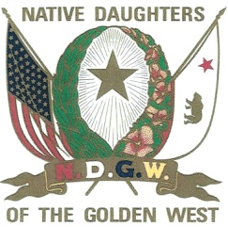
AND THE APPRECIATION OF ITS HISTORY, WILDLIFE AND LANDSCAPE

